Problem Solving and Scalability Technical Annex Document

Contents
1. Technical Annex Objectives 2
2. Phase 1 – Participation Matrix 2
Python Code – Set companies 2
Python Code – Create List of Lists 2
Python Code – DataFrame 2
Python Code – Set Seed 3
Python Code – Participation Computation 3
Python Function Information – main() 3
Python Function Information – create_matrix_set_seed() 4
Python Function Information – Compute_Participation_non-markovian() 4
Python Code – Compute_Participation_markovian() 4
Python Function Information – compute_participation_markovian() 4
Phase one recap 5
Phase 2 – Corporate Control 5
Python Code – Corporate Control Algorithm 5
Python Function Information – Corporate_Control() 5
Phase two recap 6
Phase 3 – Scalability Testing 7
Python code – Scalability_testing() 7
Python Function Information – scalability_testing() 7
Plot Results 8

Technical Annex Objectives

- Describes my analysis of the problems
- Describes my algorthmic solution and the Python code for it
- Describes the scalability analysis of my code, tested against random instances of the problem

Phase 1 – Participation Matrix

Below outlines each problem, I have included analaysis and solution.

A set of companies identified by integers over 0….n-1

We can have any number of companies, I will let the user choose.

Python Code – Set companies
print("Please enter total number of companies: ")
companies = int(input()) # total number of companies

A cross participation matrix A: a[i][j] represents the percentage of capital that company i holds of company j.

The rows represent the different companies, the columns represent the different stakes held in each company.

Python Code – Create List of Lists
a = [[0 for i in range(companies)] for j in range(companies)]

The above line of code creates a list of lists of equal length. The length being the total number of companies which is inputted by the user.
To display the list in the form of a matrix I will import pandas and use the “DataFrame” function.

Python Code – DataFrame
print(pd.DataFrame(a))

The above code displays the list in the form of a matrix.
An arbitray company s (for seed)
The user gets to select the seed company, and we seed the control structure with a[s][s]=1

Python Code – Set Seed
s = int(input()) # seed_company
a[s][s] = 1

Participation Computation including other rules
  - a[i][i] = 0: All other companies apart from the seed company sell 100% of their shares keeping none. Hence the main diagonal will be 0 everywhere but for s.
  - In general a[i][j] <> a[j][i]: This means if I own 70% of Tesco’s, this does not automatically mean Tesco own 70% of me.

Python Code – Participation Computation
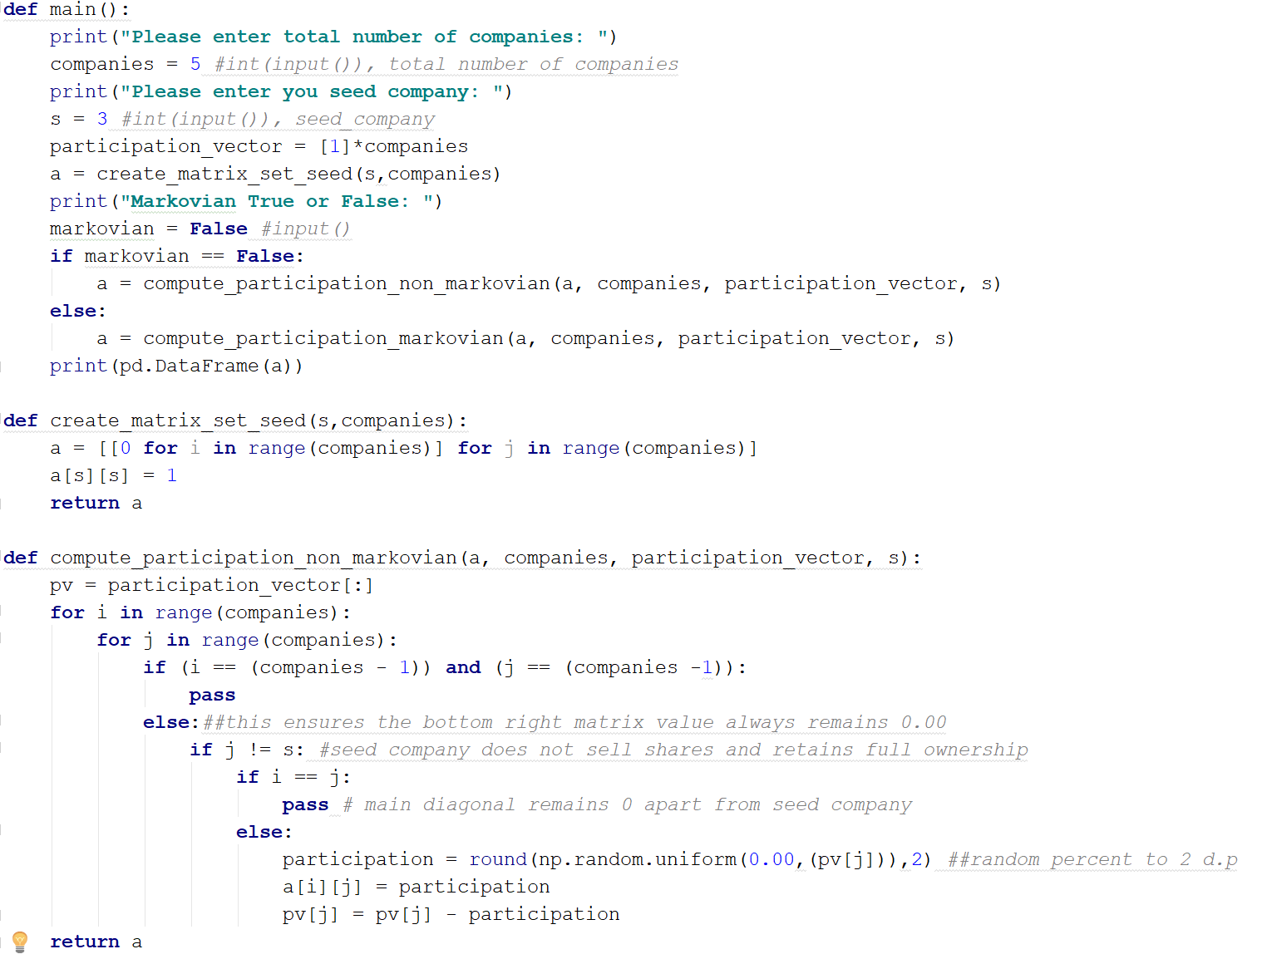

Python Function Information – main()
- Companies parameter is set
- Seed company parameter is set
- Participation vector is created. This is to ensure we do not go over 100% participation.
- Set markovian to true or false, if true all columns will equal 100%
- Call funtions create_matric_set_seed & compute participation
- Print DataFrame

Python Function Information – create_matrix_set_seed()
- create matrix and set it equal to “a”, each list is inserted with “companies” number of elements, where each element is equal to 0. There are “companies” number of lists in “a”.
- seed control by apply a[s][s] is equal to 1.

Python Function Information – Compute_Participation_non-markovian()
- Create a hard copy of “pv” (participation vector)
- Iterate through lists of lists
- if j != s, this means we do not sell any of our seed company shares
- Pass when i=j, because main diagonal remians 0 and seed remains 1
- Use random function to calculate the participation, ensuring we do not sell over 100% by dynamically updating the max range of the random function. We dynamically update the max range of the random function by utilising our “pv” (participation vector)

Python Code – Compute_Participation_markovian()
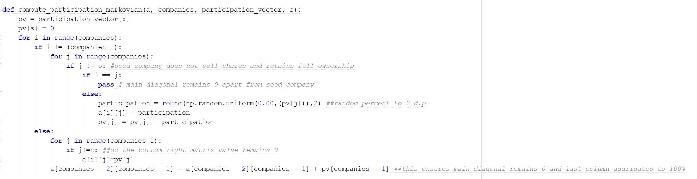

Python Function Information – compute_participation_markovian()
- Create a hard copy of “pv” (participation vector)
- Iterate through lists of lists
- if j != s, this means we do not sell any of our seed company shares
- Pass when i=j, because main diagonal remians 0 and seed remains 1
- Use random function to calculate the participation, ensuring we do not sell over 100% by dynamically updating the max range of the random function. We dynamically update the max range of the random function by utilising our “pv” (participation vector)
- To ensure all columns equal 100%
  - Instead of calculating the last row of participations using random as before, instead we, insert our remaining participations from “pv” (participation vector) into the last row.
  - However, we must remember that the main diagonal must remain “0” therefore the bottom right value must remain 0. We skip the bottom right value and we hard code the second from last companies participation in the last company with the remaining amount. This ensures the main diagonal stays 0 (apart from the seed company) and all columns calculate to 100%.
    - If the last company is the seed company, the parameter pv[s] = 0, mean we insert a ‘0’ in this instance.

Phase one recap
I have computed a realistic instance of cross-participation as non of my columns go over 100%, to enforced this I introduced a participation vector (pv) whereby I draw down of the the available shares.
To calculate the participations my code iterates through each value in the matrix and assigns a dynamically created random participation. The reason why I refer to the random participation as dynamically created is because the random-max-range is updated each time with the remaining available shares.
To enforce the markovian instances I asign the last available shares out instead of randomally calculating their participation.

Phase 2 – Corporate Control
Below outlines my corporate control alogrithm.

Python Code – Corporate Control Algorithm
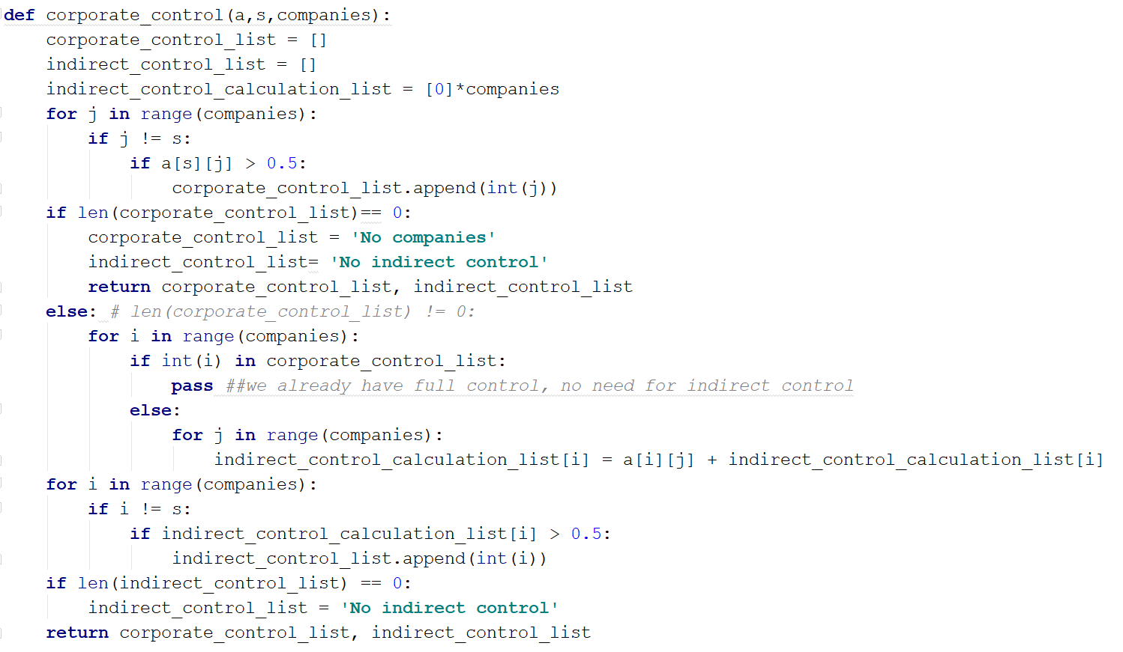

Python Function Information – Corporate_Control()
To compute corporate and indirect control I first created three lists. As mention below:
- Corporate_control_list
  - I created an empty list
  - I iterate through the shares that the seed company owns in the other companies. If the value of the shares is over 50% I append the company number to the corporate_control_list
  - I skip over the seed company share amount, I do not want to add it to the corporate_contol_list as I have full control of the seed company.
  - If my list is empty after point b, I return string values “No companies” and “No indirect companies”
- Indirect_control_calculation_list
  - I create a list and add 0 * “companies” to the list.
  - If my corporate_control_list is not empty, I iterate through the matrix and aggrigate the shares that the seed and each controlled company ownes in every other company.
- Indirect_control_list
  - Once I have finished part 2 above (aggrigating the share amounts), I itergate through the indirect_control_calculation_list and if the value of the shares is over 50% I append the company number to the indirect_conrol_list.
  - I skip over the seed company share amount, I do not want to add it to the indirect_contol_list as I have full control of the seed company.

Phase two recap
I have tested my algorithm over many different instance of n.
My code avoids ‘magic numbers’ therefore it is suitable for all instances of n.
My code skips the seed company while creating the corporate and indirect control company lists.
When my algorithm calculates the indirect share amounts it includes the seed company shares and corporate controlled company shares. I avoid duplication and do not include the corpoarate controlled companies in the indirect list.

Phase 3 – Scalability Testing
To get good variation I have used 2^k instead of 10^k.

Python code – Scalability_testing()
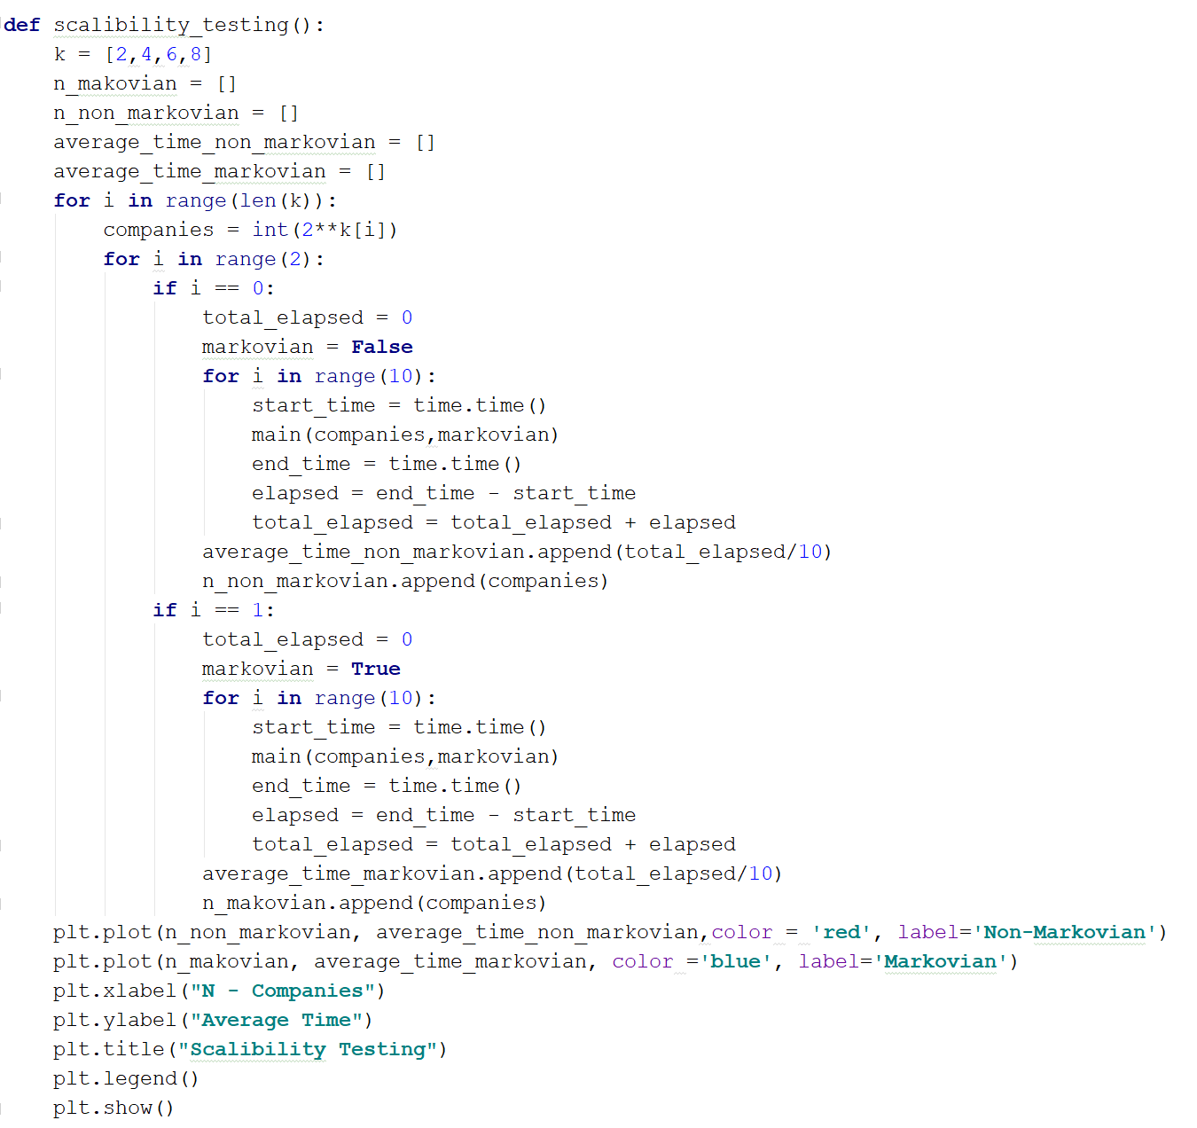

Python Function Information – scalability_testing()
I create and populate 5 lists as mentioned below.
- List K
  - This is used to compute the different variation of n-companies as per the specification document.
- N_markovian
  - This list is used to store the n value (n = 2**k) for the markovian instance(companies, x-axis)
- N_non_markovian
  - This list is used to store the n value (n = 2**k) for the non markovian instance(companies, x-axis)
- Average_time_non_markovian
  - This list is used to store the average elapsed times for the non markovian instances
  - I pass into the main function the n-companies value and markovian is set to False.
  - I record the start time before calling main() and record the end time after main() has finished, I record the total elapsed time, which is the difference between the end and start times. I repeat this 10 times, storing the total elapsed times and compute the average time by dividing by 10. I repeat this process for each value of k and store the average time in the list.
- Average_time_markovian
  - This list is used to store the average elapsed times for the markovian instances
  - I pass into the main function the n-companies value and markovian is set to True.
  - I record the start time before calling main() and record the end time after main() has finished, I record the total elapsed time, which is the difference between the end and start times. I repeat this 10 times, storing the total elapsed times and compute the average time by dividing by 10. I repeat this process for each value of k and store the average time in the list

Plot Results
Using lists as mentioned above (see 2,3,4 & 5), I plot the results using matplotlib
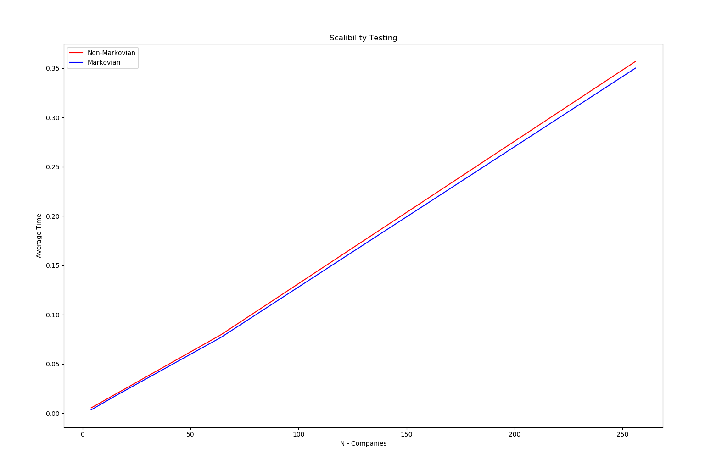
- The result increase fairly linearly, I would expect for larger values of k for the line to increase exponentually.
- Interesting my Markovian computation consistantly completes quicker than my Non-markovian instance. I would relate this to the fact that when computing my markovian instances I do not iterate through the last company row instead I hard code the left over available company shares. My chart proves that hard coding the left over available shares is a quicker and less costly process.

